Final Project Report

E-Drug Store Administration



Project Supervisor

<<Sir Asad-Ullaha>>

Submitted By

Ahmad Arshad BC170202448

Software Projects & Research Section,

Department of Computer Sciences,

Virtual University of Pakistan

|  |
| --- |
|  |



CERTIFICATE

This is to certify that Ahmad Arshad (BC170202448) have worked on and completed their Software Project at Software & Research Projects Section, Department of Computer Sciences, Virtual University of Pakistan in partial fulfillment of the requirement for the degree of BS in Computer Sciences under my guidance and supervision.

In our opinion, it is satisfactory and up to the mark and therefore fulfills the requirements of BS in Computer Sciences.

Supervisor / Internal Examiner

<<Sir Asad-Ullaha>>

Supervisor,

Software Projects & Research Section,

Department of Computer Sciences

Virtual University of Pakistan

___________________

(Signature)

External Examiner/Subject Specialist

<<External Supervisor Name>>

___________________

(Signature)

Accepted By:

_____________

(For office use)

EXORDIUM

In the name of Allah, the Compassionate, the Merciful.

Praise be to Allah, Lord of Creation,

The Compassionate, the Merciful,

King of Judgment-day!

You alone we worship, and to You alone we pray for help,

Guide us to the straight path

The path of those who You have favored,

Not of those who have incurred Your wrath,

Nor of those who have gone astray.

DEDICATION

This project is dedicated to my family and my university as both worked really well to make a better future for me. I also dedicate this project to my teacher specially collage teachers who always support me and help me taking right decision. And under their guidance I have crossed this millstone of my life as without all of them it is not possible.

ACKOWLEDGEMENT

This project consumed a lot of effort however I enjoy working and finishing this project as this is the first real time project for me. Today I would like to thank my project instructor Sir Asad-Ullaha for guiding me throughout the project and always present whenever I need help. I also want to show my respect to all the free stuff that is available online the free courses and other open source project which gives me enough knowledge and exposure to the development.

PREFACE

University gave me various project to choose between at that time I was only familiar with java and c++. That’s why I decided to choose one of the java project which was written in the projects file. However I did not have an idea that java project was on favorite list of many student that’s why in the selection day it was already selected by maximum number of students before I select it. This project was one of the remaining project whom the students are not completed yet. I selected the project however it was one of the best strategies which happened in my life because of this now I am familiar with python also and I am kind of like it.

Sometimes while making this project I feel like I may not make it to the finish line however I burnt my oil work hard believe in myself and now with the grace of Allah I have completed this project

Table of Contents

*Chapter 1* 8

*Gathering and Analyzing info* 8

Introduction 9

Project Purpose 9

Software Features 9

Operating Environment 9

Scope 9

Definitions, Acronyms and Abbreviations 10

Project Requirements: 11

User Requirements 11

Functional Requirements 11

Non Functional Requirements 13

*Chapter 2* 15

*Designing the project* 15

# Chapter 1

# Gathering and Analyzing info

## Introduction

### Project Purpose

The main object of E-Drug Store Administration is to provide the medical stores and medical professionals the service to aid in their regular work through the software which will manage sale purchase, medicine details, the stock information and the profit loss of the month or year etc.

### Software Features

* Saves the information about the sale purchase.
* Save the Medicine information, its price, uses and similar medicines for the same kind of disease etc. in Database.
* Can generate a receipt for every customer.
* Automatically delete the item from the stock after sale.
* Save the information about the stock.
* Can generate a profit loss table of a day, week, month or year.
* Can tell you the items which are low in stock and needed to purchase.
* User Friendly and Fast

### Operating Environment

It is a window based application that will run on all window operating systems.

## Scope

The scope of this project is to provide the medical store staff and medical professionals the service to aid in their regular work through the software which will manage the inventory which further includes sale purchase, profit loss reports and the stock information. Another main function that this software exhibit is that it will help the salesmen of store to see the item price, to check whether the following medicine is available or not what are the certain ingredients in that item or medicine. Moreover it will also provide two types of account Admin account and the user (Salesmen) Account. Both the Admin and the User have to login first to launch an instant of the software. The managing of stock and the inventory would be in the responsibility of the admin it he or she can only check the inventory make sale or purchase reports, can add the new users, modify the stock which further includes addition , updating the existing medicine records and removal of the decline medicines. In contrast to the user account which can only search for the medicine get its details sale the medicine and can print the receipt. Software have some restriction or u can say the authorize level for both account as them both are for different purposes, for example the user can’t add stock can’t make report or anything that is the work of admin user can’t perform.

## Definitions, Acronyms and Abbreviations

Used Abbreviations and Acronyms:

1. DS: Drug Store
2. AD: Administrator
3. FR: Functional Requirement
4. US: Use Case
5. ADDMED: Add Medicine
6. UPDMED: Update Medicine Details
7. DELMED: Delete a medicine Details
8. ADDUSER: Add new User
9. DELUSER: Delete a user
10. INVEN: inventory
11. SEMED: Searching medicine
12. SELMED: Selling medicine

## Project Requirements:

### User Requirements

E-Drug stores will have two types of users one is administrator and the second is normal salesperson (User).

|  |  |
| --- | --- |
| Requirements of Administrator | Requirements of User |
| Can create a new User |  |
| Can add the new stock to Database |  |
| Can add, delete or modify the details of an items in Database |  |
| Can search for the items through name, id and salt in Database. | Can search for the items through name, id and salt in Database. |
| Can generate receipts for the customers. | Can generate receipts for the customers. |
| Can generate the profit loss reports. |  |

### Functional Requirements

Administrator:

* Login/Logout
* Add a new Medicine detail
* Edit an existing medicine Details
* Delete a medicine
* Add a new User Account
* Delete a User Account
* Can manage the inventory, Profit loss Reports.
* Can sell items

User:

* Login/Logout
* Can search items
* Can sell items form the stock
* Can look at the price of the medicines available.
* Can modify the stock only through sell of the items.
* Can generate and print receipts for Customers

#### Details of Functional Requirements

* Login/Logout:

User can login and logout using his credentials which was given to him/her by the administrator of the store after starting the application user will put his/her credentials otherwise he we not be able to perform or use the app he will only see a login screen and after putting only the right credentials he/she will be able to utilize software if he is admin the admin panel would pop up if he is a salesmen then salesmen panel would pop up.

* Adding a new medicine

In E-DRUG STORE only admin can add new medicine to add a medicine he first need to login using his credentials then clicking update stock button to add the stock would show the previous stock and some entries and button with them admin can add a new medicine. Id of the medicine would be assigned automatically admin only have to write name, type, quantity, sell price, purchase, salt and company name in the relevant box them after pressing add button it will show the added successful status or show the relevant error in the database or entry field.

* Editing or updating an existing medicine record

In E-Drug store administration adding and updating a medicine record is almost same as adding a new medicine record. While updating a medicine a record you can change almost everything except the id and name of the medicine As id is automatically set by the database and name is the identifier of the medicine you can change quantity price company type of the existing medicine. And also only admin can change the details of medicines.

* Delete a medicine

Firstly admin can delete a medicine record. Secondly in the admin panel selecting the update stock GUI would open and show the medicines record and other information admin can select a medicine my activating it in tree view panel and them pressing delete button on the bottom of the frame. Another method for deleting the record is by writing the complete name of the medicine and then pressing the delete button.

* Add new user

Only admin can add new user. After login the admin panel would appear and by selecting the update user button admin would be shown with user information and have button to perform certain action’s regarding users to add a new user admin will enter name, designation, address phone number, joining date and date of birth in the relevant field. Then press the add user button either he got added successful message or the relevant error regarding database or entry fields.

* Delete a user

Only admin can delete the user. After login the admin panel would appear and by selecting the update user button admin would be shown with user information and will be shown some buttons to perform certain actions. Admin can select a user and then by pressing the delete button the user would be deleted.

* Managing the inventory

Both admin and the sales men can manage the inventory. For managing the inventory the steps are same. First admin or salesmen would enter their credentials to login then in both of them would be provided with manage inventory button then the GUI function would appear their they can sale item make receipts, print slips and many other things to manage inventory

* Make reports

Only admin can make report. First admin has to login the admin panel he would press the report button then would be provide with button having the time period on it them there would also be a function to select the custom duration of the button after selecting the button of make report in the project directory the sales, purchase and profit loss report would be written in an xml file.

* Search item

In the inventory function there would be three boxes where one can search an item in the id box user (admin or salesmen) can put id of the medicine and would be provided with some details like salt type price and quantity in the store other search box is search by name where user can search an item by name and after the software found the item he will be provided with details of the medicine like the search by id does. Third and last search would be search by salt when user would put the salt of the medicine and would be provided with medicines which have the regarding salt

* Sell an item

Both the admin and salesmen can sell item in the inventory function there is a proper form first one have enter the medicine name or id in the relevant field and press search or enter button on the keyboard then the details of that medicine would be shown in the details item tab there you have to put the quantity of the medicine how much you want to put in cart Then after fill up the cart on the search by name entry one can directly go to name entry of the customer name or Ctrl + p key to go the customer name entry and after press enter or press the sell soft button user will go to the print receipt page

### Non Functional Requirements

1. We will use the database for better reliability and security of the software.
2. We have authorize the right to add medicine and add new users to admin only for better security options. In addition it have a benefit that admin is responsible for the stock, medicine prices, medicine position in the store and the stock information.
3. We will use the light weight GUI Frame Work that will speed up the overall performance
4. By searching a medicine user would be shown all the information of that medicines like its ingredients, formula formations and prices which would improve the user experience.
5. There would be button of backup that user can use to back up the database file into other places of computer
6. Software will store the location of the medicine in the store so that it would be easy for the sales men to find a certain medicine which will save much time.

## Use Cases and Usage Scenarios

### Use case diagram:

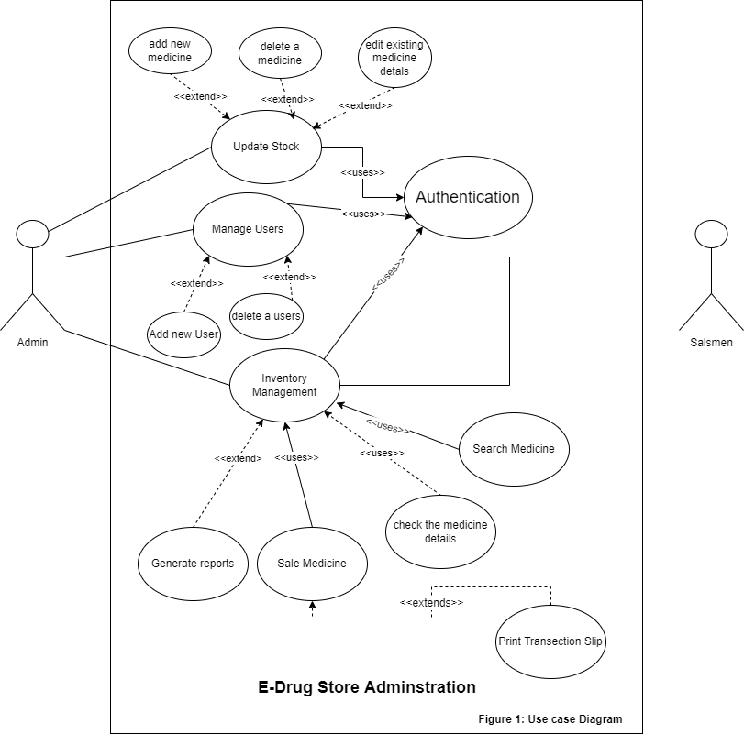

### Usage scenarios:

|  |  |  |
| --- | --- | --- |
| Use Case Title | Authentication | |
| Use Case ID | DS-AUTH-US_001 | |
| Requirement ID | DS-FR-0001 | |
| Actor | Admin. User | |
| Description: This use case is for the authentication of the users (Login/Logout). When a user will open the application he/she will have to authenticate him/herself by putting the credentials assign to him/her. | | |
| Pre-Condition :  User have been registered before.  He/She have put the correct credentials. | | |
| Task Sequence | | Exceptions |
| 1. User will open the application | |  |
| 1. User put his or her credential in the login page and press the login button | | System may show user authentication exceptions. |
| Post Conditions :  User will be promoted with his working environment as if he is logged in as admin or the normal User(Salesmen) | | |
| Un-Resolved Issues: | | |
| Authority : | | |
| Modification History : <1.0>  Author: E-Drug Store Administration | | |

|  |  |  |
| --- | --- | --- |
| Use Case Title | Update Stock | |
| Use Case ID | DS-UPMED-US_002 | |
| Requirement ID | DS-AD-FR-0002 | |
| Actor | Admin | |
| Description: The use case is for the administrator to update stock | | |
| Pre-Condition :  User much be logged in as an Admin | | |
| Task Sequence | | Exceptions |
| 1. User will open the application | |  |
| 1. User put his or her admin credential in the login page | | System may show user authentication exceptions. |
| 1. User will click on the Update Stock button | |  |
| Post Conditions :  Admin will be given an interface to add stock where there are different options like add, edit delete or remove a medicine. | | |
| Uses | Authentication | |
| Extends |  | |
| Un-Resolved Issues: | | |
| Authority : Administrator | | |
| Modification History : <1.0>  Author: E-Drug Store Administration | | |

|  |  |  |
| --- | --- | --- |
| Use Case Title | ADD A NEW MEDICINE | |
| Use Case ID | DS-ADDMED-US_003 | |
| Requirement ID | DS-AD-FR-0003 | |
| Actor | Admin | |
| Description: The use case is for the administrator to add new medicines to the stock | | |
| Pre-Condition :  User much be logged in as an Admin  User have clicked on update stock | | |
| Task Sequence | | Exceptions |
| 1. User will open the application | |  |
| 1. User put his or her admin credential in the login page | | System may show user authentication exceptions. |
| 1. User will click on the Update Stock button | |  |
| 1. User will click on the add new medicine button 2. User will enter the medicine name and its attributes to the add medicine form and click on the add medicine button. | | May be User will promoted with the exceptions below according to its input   1. Already have the same medicine name. 2. Invalid medicine name 3. Medicine name can’t be empty 4. Medicine quantity , Sale price or purchase price can’t be less than 1 5. Medicine quantity, Sale price or purchase price can’t be a negative value. |
| Post Conditions :  After filling the medicine form correctly system will give a popup message medicine added successfully  User will be return to the add new medicine form | | |
| Uses |  | |
| Extends | UPDATE STOCK | |
| Un-Resolved Issues: | | |
| Authority : Administrator | | |
| Modification History : <1.0>  Author: E-Drug Store Administration | | |

|  |  |  |  |
| --- | --- | --- | --- |
| Use Case Title | | EDIT EXISTING MEDICINE DETAILS | |
| Use Case ID | | DS-UPDMED-US_004 | |
| Requirement ID | | DS-AD-FR-0004 | |
| Actor | | Admin | |
| Description: The use case is for the administrator to the edit an existing medicines details | | | |
| Pre-Condition :  User much be logged in as an Admin  User have clicked on edit an existing medicine details | | | |
| Task Sequence | | | Exceptions |
| 1. User will open the application | | |  |
| 1. User put his or her admin credential in the login page | | | System may show user authentication exceptions. |
| 1. User will click on the Update stock button | | |  |
| 1. User will click on the update existing medicine button 2. User will enter the medicine name and its new attributes to the Update medicine form and click on the edit medicine button. | | | May be User will promoted with the exceptions below according to its input   1. Can’t find the medicine name 2. Invalid medicine name 3. Medicine name can’t be empty 4. Medicine quantity , Sale price or purchase price can’t be less than 1 5. Medicine quantity, Sale price or purchase price can’t be a negative value. |
| Post Conditions :  After filling the Update medicine form correctly system will give a popup message medicine Updated successfully  User will be return to the update medicine form | | | |
| Uses |  | | |
| Extends | Update Stock | | |
| Un-Resolved Issues: | | | |
| Authority : Administrator | | | |
| Modification History : <1.0>  Author: E-Drug Store Administration | | | |

|  |  |  |  |
| --- | --- | --- | --- |
| Use Case Title | | DELETE A MEDICINE | |
| Use Case ID | | DS-DELMED-US_005 | |
| Requirement ID | | DS-AD-FR-0005 | |
| Actor | | Admin | |
| Description: The use case is for the administrator to the delete a medicines details | | | |
| Pre-Condition :  User much be logged in as an Admin  User have clicked on delete medicine details | | | |
| Task Sequence | | | Exceptions |
| 1. User will open the application | | |  |
| 1. User put his or her admin credential in the login page | | | System may show user authentication exceptions. |
| 1. User will click on the update stock button | | |  |
| 1. User will click on the delete a medicine button 2. User will choose to delete a medicine by name or id, after selecting the desired option user will enter the name or id according to its choice and then click on the delete medicine button. | | | May be User will promoted with the exceptions below according to its input   1. Can’t find the medicine name 2. Medicine name can’t be empty 3. Can’t find the medicine id 4. Medicine id can’t be empty 5. Invalid medicine name 6. Invalid medicine id |
| Post Conditions :  After entering the correct name or id and pressing enter. User will be given a popup message entry deleted successfully  User will be return to the delete medicine form | | | |
| Uses |  | | |
| Extends | Update Stock | | |
| Un-Resolved Issues: | | | |
| Authority : Administrator | | | |
| Modification History : <1.0>  Author: E-Drug Store Administration | | | |

|  |  |  |
| --- | --- | --- |
| Use Case Title | Manage Users | |
| Use Case ID | DS-UPMED-US_006 | |
| Requirement ID | DS-AD-FR-0006 | |
| Actor | Admin | |
| Description: The use case is for the administrator to manage users | | |
| Pre-Condition :  User much be logged in as an Admin | | |
| Task Sequence | | Exceptions |
| 1. User will open the application | |  |
| 1. User put his or her admin credential in the login page | | System may show user authentication exceptions. |
| 1. User will click on the Manage Users button | |  |
| Post Conditions :  Admin will be given an interface to add stock where there are different options like add, edit delete or remove a medicine. | | |
| Uses | Authentication | |
| Extends |  | |
| Un-Resolved Issues: | | |
| Authority : Administrator | | |
| Modification History : <1.0>  Author: E-Drug Store Administration | | |

|  |  |  |
| --- | --- | --- |
| Use Case Title | ADD A NEW USER | |
| Use Case ID | DS-ADDUSER-US_007 | |
| Requirement ID | DS-AD-FR-0007 | |
| Actor | Admin | |
| Description: The use case is for the administrator to add a new user | | |
| Pre-Condition :  User much be logged in as an Admin  User have clicked on Manage Users Button | | |
| Task Sequence | | Exceptions |
| 1. User will open the application | |  |
| 1. User put his or her admin credential in the login page | | System may show user authentication exceptions. |
| 1. User will click on the manage user buttons 2. User will click on the add new user button | |  |
| 1. User will choose to create an admin account or a sales men account 2. Enter his name and press create | | May be User will promoted with the exceptions below according to its input   1. User already exist 2. User name can’t be empty 3. Invalid user name |
| Post Conditions :  After filling the new user form. User will be given a popup message created user successfully.  User will be return to the create user form | | |
| Uses |  | |
| Extends | Manage Users | |
| Un-Resolved Issues: | | |
| Authority : Administrator | | |
| Modification History : <1.0>  Author: E-Drug Store Administration | | |

|  |  |  |
| --- | --- | --- |
| Use Case Title | DELETE A USER | |
| Use Case ID | DS-DELUSER-US_008 | |
| Requirement ID | DS-AD-FR-0008 | |
| Actor | Admin | |
| Description: The use case is for the administrator to delete a user | | |
| Pre-Condition :  User much be logged in as an Admin  User have clicked on Manage Users | | |
| Task Sequence | | Exceptions |
| 1. User will open the application | |  |
| 1. User put his or her admin credential in the login page 2. User have clicked on the Manage Users button | | System may show user authentication exceptions. |
| 1. User will click on the delete user button | |  |
| 1. User will enter his name and press delete user. | | May be User will promoted with the exceptions below according to its input   1. User doesn’t exist 2. User name can’t be empty 3. Invalid user name |
| Post Conditions :  After filling the deleting user form. User will be given a popup message deleted user successfully.  User will be return to the delete user form | | |
| Uses |  | |
| Extends | Manage Users | |
| Un-Resolved Issues: | | |
| Authority : Administrator | | |
| Modification History : <1.0>  Author: E-Drug Store Administration | | |

|  |  |  |  |
| --- | --- | --- | --- |
| Use Case Title | Inventory Management | | |
| Use Case ID | DS-INVEN-US_009 | | |
| Requirement ID | DS-AD-FR-0009 | | |
| Actor | Admin | | |
| Description: The use case is for the administrator to manage inventory. | | | |
| Pre-Condition :  User much be logged in as an Admin | | | |
| Task Sequence | | | Exceptions |
| 1. User will open the application | | |  |
| 1. User put his or her admin credential in the login page | | | System may show user authentication exceptions. |
| 1. User will click on the Inventory management button | | |  |
| Post Conditions :  User will be given the inventory management menu | | | |
| Uses | | Authentication | |
| Extends | |  | |
| Un-Resolved Issues: | | | |
| Authority : Administrator | | | |
| Modification History : <1.0>  Author: E-Drug Store Administration | | | |

|  |  |  |  |
| --- | --- | --- | --- |
| Use Case Title | Generate Reports | | |
| Use Case ID | DS-INVEN-US_010 | | |
| Requirement ID | DS-AD-FR-0010 | | |
| Actor | Admin | | |
| Description: The use case is for the administrator to generate report about inventory | | | |
| Pre-Condition :  User much be logged in as an Admin  User have clicked on Inventory management | | | |
| Task Sequence | | | Exceptions |
| 1. User will open the application | | |  |
| 1. User put his or her admin credential in the login page | | | System may show user authentication exceptions. |
| 1. User will click on the Inventory management button | | |  |
| 1. User will be given with choices buttons like generate profit loss reports or generate stock valuation and quantity. | | |  |
| 1. User will again asked about the duration like daily, weekly, monthly or custom date | | | May be User will promoted with the exceptions below according to its input in custom date   1. Invalid Date |
| Post Conditions :  After getting the reports user will be given a message of printing the report or saving in computer.  User will be return to the inventory management. | | | |
| Uses | |  | |
| Extends | | Inventory management | |
| Un-Resolved Issues: | | | |
| Authority : Administrator | | | |
| Modification History : <1.0>  Author: E-Drug Store Administration | | | |

|  |  |  |
| --- | --- | --- |
| Use Case Title | SEARCH MEDICINE | |
| Use Case ID | DS-SEMED-US_011 | |
| Requirement ID | DS-USER-FR-0001 | |
| Actor | User | |
| Description: The use case is for the salesmen to search a medicine | | |
| Pre-Condition :  User much be logged in as an normal user | | |
| Task Sequence | | Exceptions |
| 1. User will open the application | |  |
| 1. User put his or her salesmen credential in the login page | | System may show user authentication exceptions. |
| 1. User will enter the medicine name id or its base formula and press Search | | May be User will promoted with the exceptions below according to its input   1. Can’t find the medicine name 2. Medicine name can’t be empty 3. Can’t find the medicine id 4. Medicine id can’t be empty 5. Invalid medicine name 6. Invalid medicine id |
| Post Conditions :  After pressing enter user will get the details of medicines | | |
| Uses | Authentication | |
| Extends |  | |
| Un-Resolved Issues: | | |
| Authority : User | | |
| Modification History : <1.0>  Author: E-Drug Store Administration | | |

|  |  |  |
| --- | --- | --- |
| Use Case Title | SELL MEDICINE | |
| Use Case ID | DS-SELMED-US_012 | |
| Requirement ID | DS-USER-FR-0002 | |
| Actor | User | |
| Description: The use case is for the salesmen to get details of a medicine | | |
| Pre-Condition :  User much be logged in as an normal user | | |
| Task Sequence | | Exceptions |
| 1. User will open the application | |  |
| 1. User put his or her salesmen credential in the login page | | System may show user authentication exceptions. |
| 1. User will click on the search medicine button 2. User will enter the medicine name id or its base formula and press Search | | May be User will promoted with the exceptions below according to its input   1. Can’t find the medicine name 2. Medicine name can’t be empty 3. Can’t find the medicine id 4. Medicine id can’t be empty 5. Invalid medicine name 6. Invalid medicine id |
| 1. User will select the medicine enter the quantity and press print | | Maybe user will promoted with the exceptions below according to its inputs   1. Sell quantity can’t be greater than the stock quantity. 2. Invalid quantity 3. Printer not connected or not found |
| Post Conditions :  After pressing getting print user will again redirected to the search medicine GUI | | |
| Un-Resolved Issues: | | |
| Uses | Search Medicine | |
| Extends |  | |
| Authority : User | | |
| Modification History : <1.0>  Author: E-Drug Store Administration | | |

## Development methodology

### Chosen Methodology

Software development methodologies are also known as system development methodologies. Actually this is system development life cycle, or it can be called System Development Process. Software development methodologies are frames that are used to structure, control and plan the process of developing system.

For this project I find vu process model best as it has several advantages

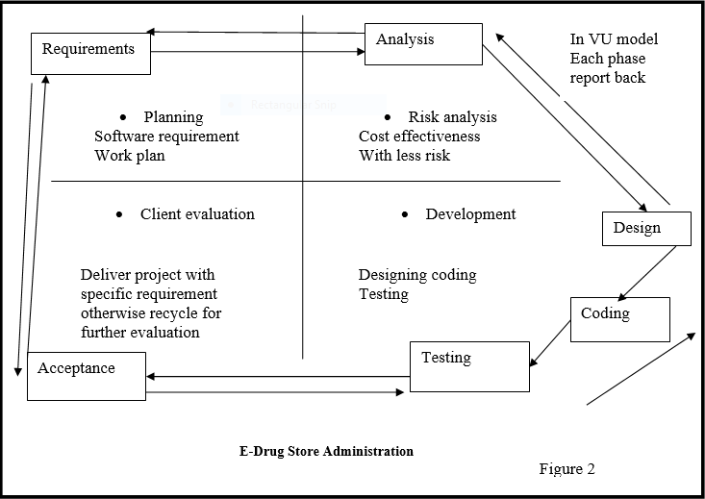

VU Process Model

The above is VU process model which is combination of waterfall and spiral models. It has five phases first one is learning and analyzing requirements secondly making of SRS third Test phase 1 fourthly Test Phase 2 and at the end Final deliverable .In the requirement phase system goals services and constraints are established after discussion with users.

### Reason for Chosen Methodology

The main knowledge behind this model is that to get the benefits of both these models. Basically, Water Fall Model is a framework for software development in which development proceeds chronologically through a sequence of phases, starting with system requirements analysis and leading up to product release and preservation, whereas the key characteristics of spiral model is risk management at regular points in the whole software development cycle. In VU Process Model we will be working in phases to complete our given project.

* This is sequenced model
* This model is easy to understand and use
* Each phase has specific deliverable
* In this model phases are completed and processed one at a time.
* Avoidance of risk is enhanced.
* Additional functionality can be added later.
* This model is used when cost and risk evaluation is important.
* This methodology is also used when users are unsure of their requirement.

It is also used when significant changes are expected.

### Work Plan Gantt chart

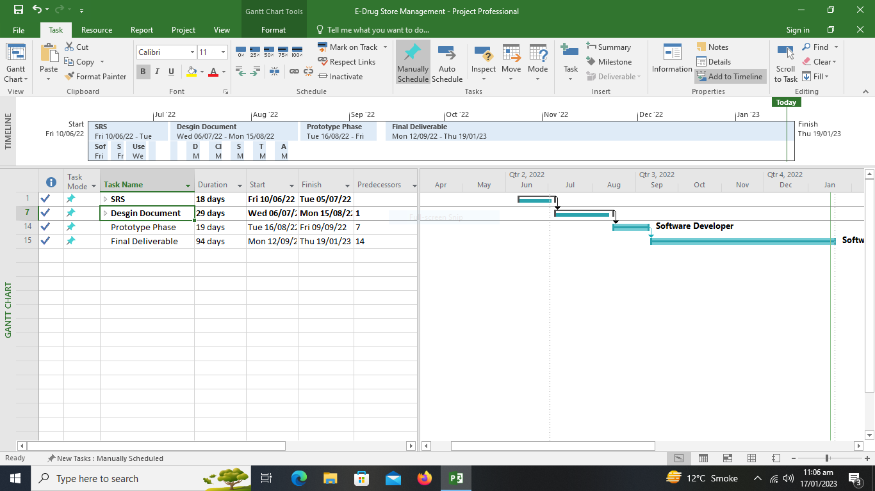

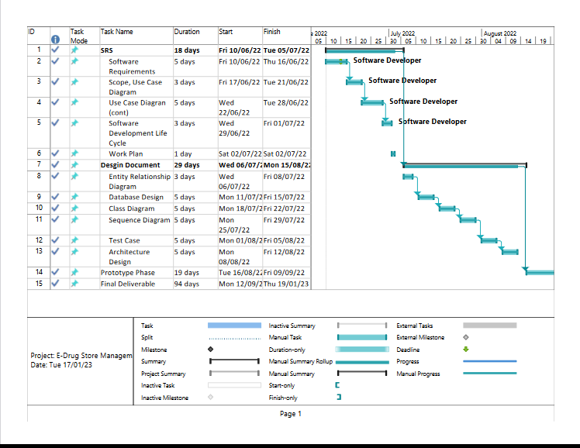

### Project Schedule (Submission Calendar)

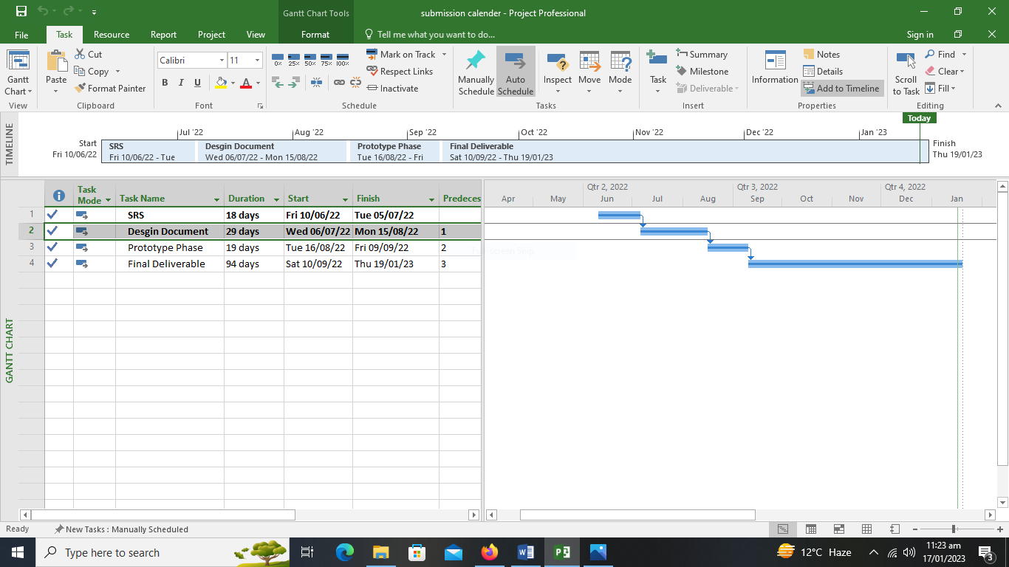

# CHAPTER 2

# Designing the Project

## Introduction

### Project Purpose

The main object of E-Drug Store Administration is to provide the medical stores and medical professionals the service to aid in their regular work through the software which will manage sale purchase, medicine details, the stock information and the profit loss of the month or year etc.

### Software Features

* Saves the information about the sale purchase.
* Save the Medicine information, its price, uses and similar medicines for the same kind of disease etc. in Database.
* Can generate a receipt for every customer.
* Automatically delete the item from the stock after sale.
* Save the information about the stock.
* Can generate a profit loss table of a day, week, month or year.
* Can tell you the items which are low in stock and needed to purchase.
* User Friendly and Fast

### Operating Environment

It is a window based application that will run on all window operating systems.

## Scope

The scope of this project is to provide the medical store staff and medical professionals the service to aid in their regular work through the software which will manage the inventory which further includes sale purchase, profit loss reports and the stock information. Another main function that this software exhibit is that it will help the salesmen of store to see the item price, to check whether the following medicine is available or not what are the certain ingredients in that item or medicine. Moreover it will also provide two types of account Admin account and the user (Salesmen) Account. Both the Admin and the User have to login first to launch an instant of the software. The managing of stock and the inventory would be in the responsibility of the admin it he or she can only check the inventory make sale or purchase reports, can add the new users, modify the stock which further includes addition , updating the existing medicine records and removal of the decline medicines. In contrast to the user account which can only search for the medicine get its details sale the medicine and can print the receipt. Software have some restriction or u can say the authorize level for both account as them both are for different purposes, for example the user can’t add stock can’t make report or anything that is the work of admin user can’t perform.

## Definitions, Acronyms and Abbreviations

Used Abbreviations and Acronyms:

1. DS: Drug Store
2. AD: Administrator
3. FR: Functional Requirement
4. US: Use Case
5. ADDMED: Add Medicine
6. UPDMED: Update Medicine Details
7. DELMED: Delete a medicine Details
8. ADDUSER: Add new User
9. DELUSER: Delete a user
10. INVEN: inventory
11. SEMED: Searching medicine
12. SELMED: Selling medicine

## Architectural Representation (Architecture Diagram)

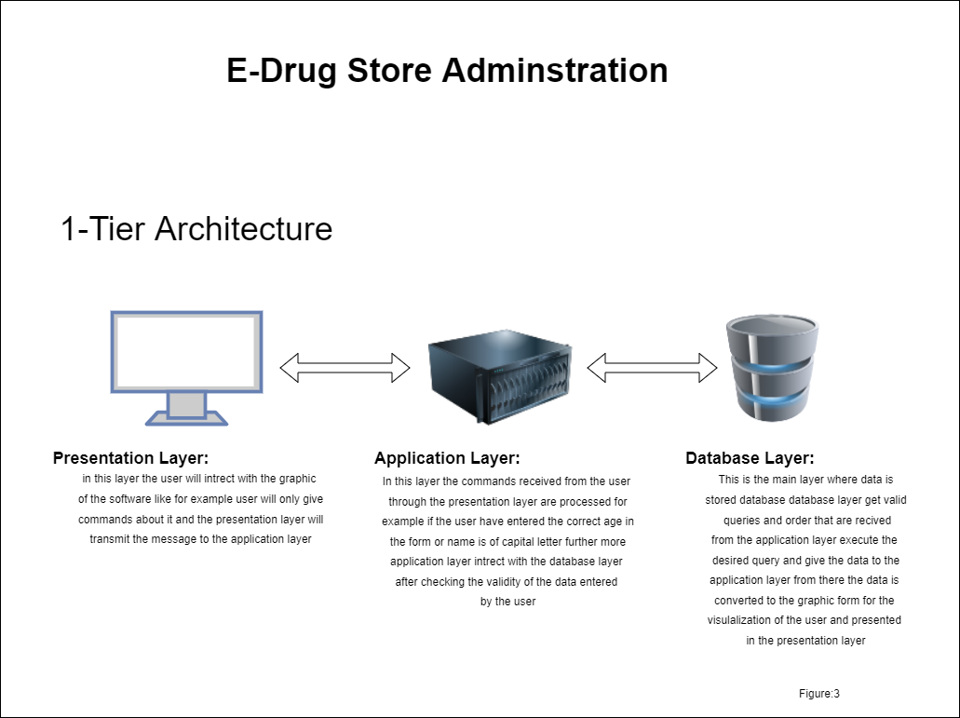

## Dynamic Model: Sequence Diagrams

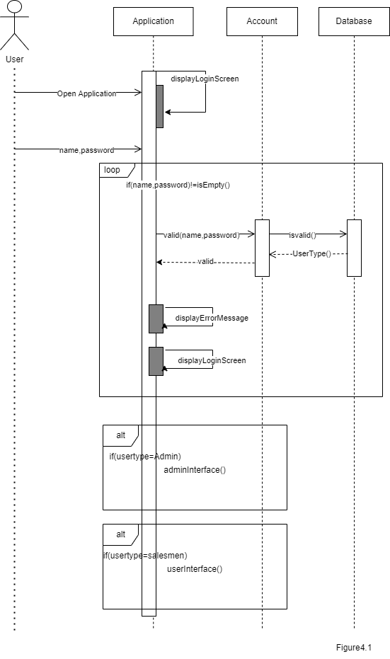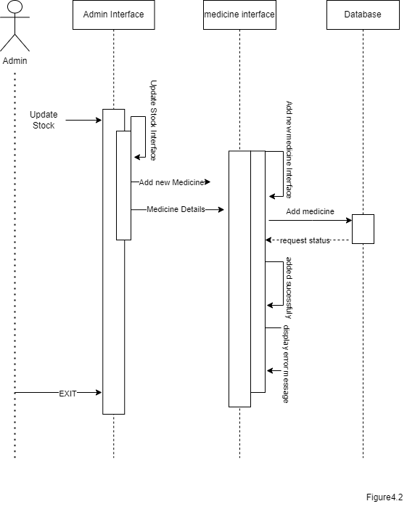

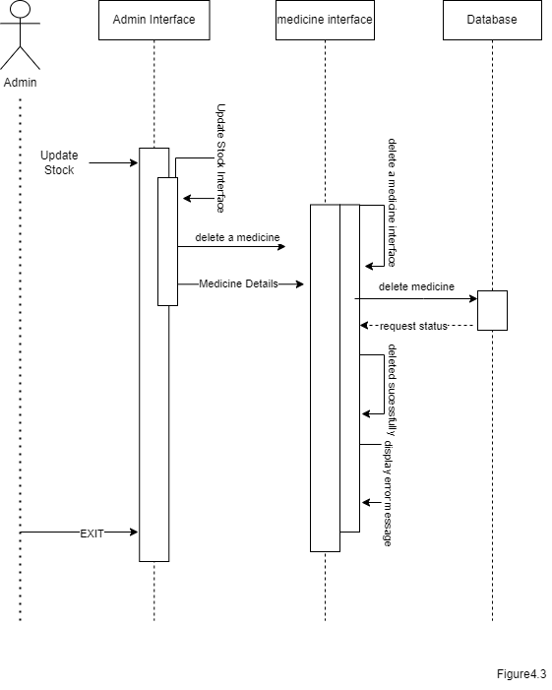

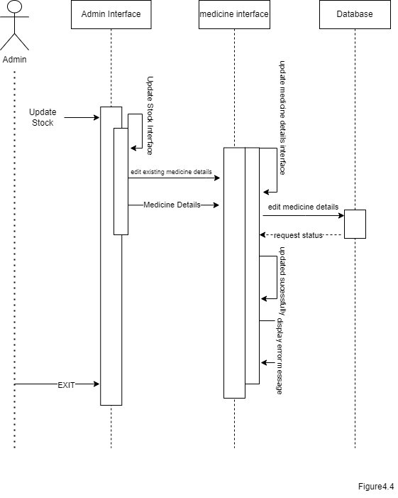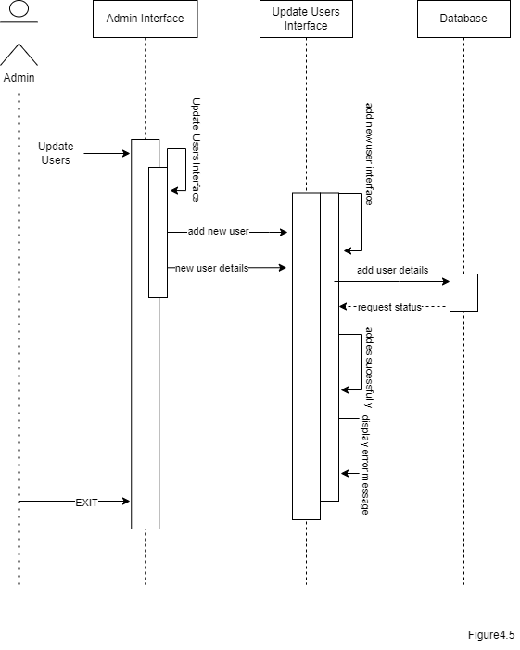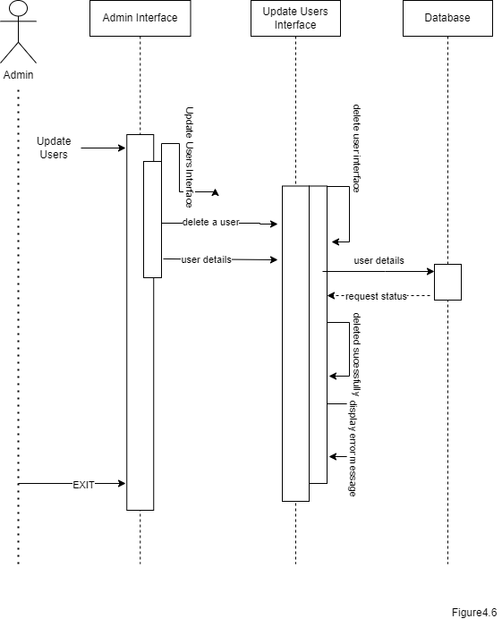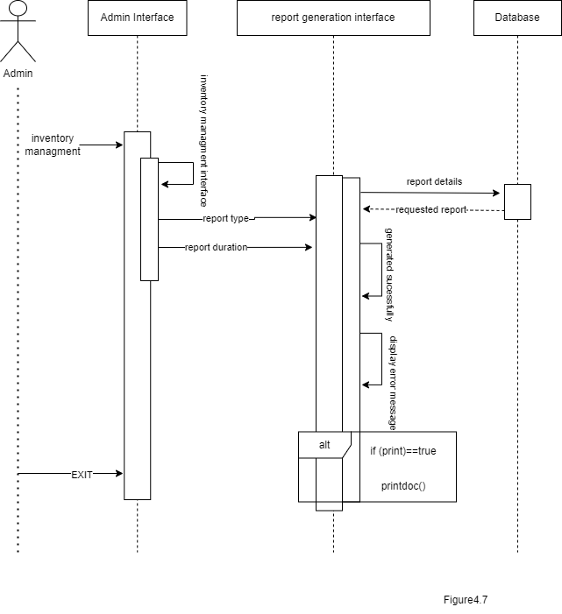

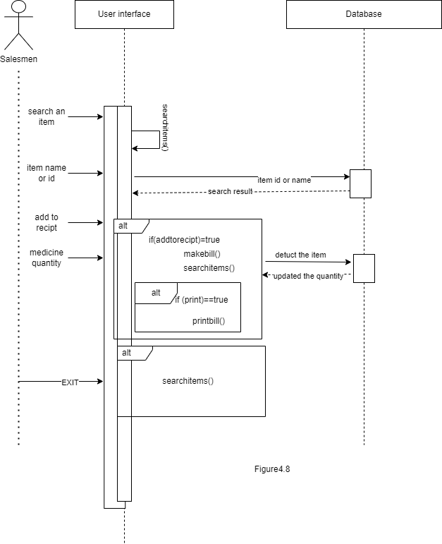

## Object Model/Logical Model: Class Diagram

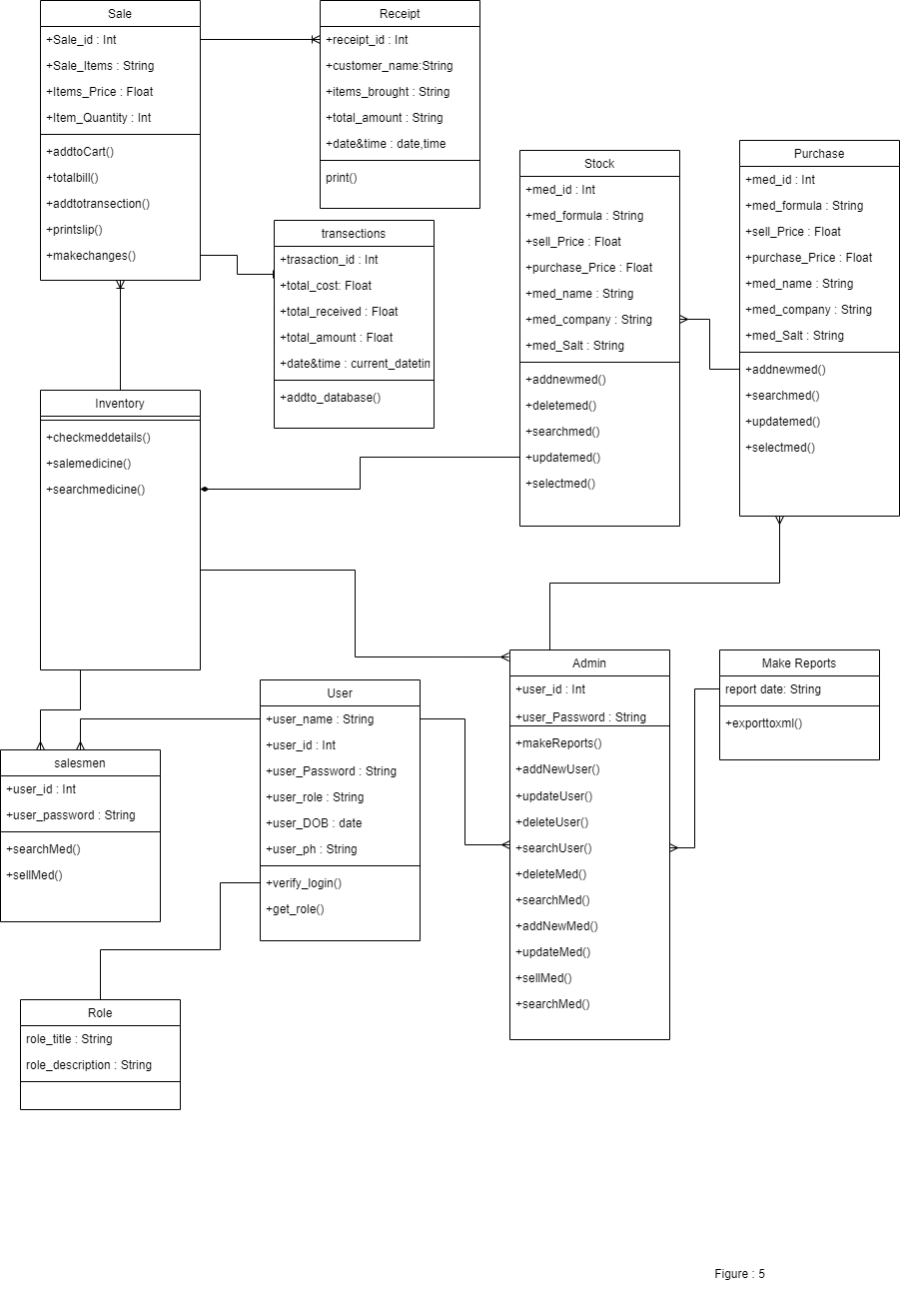

## Database Model (Database Diagram)

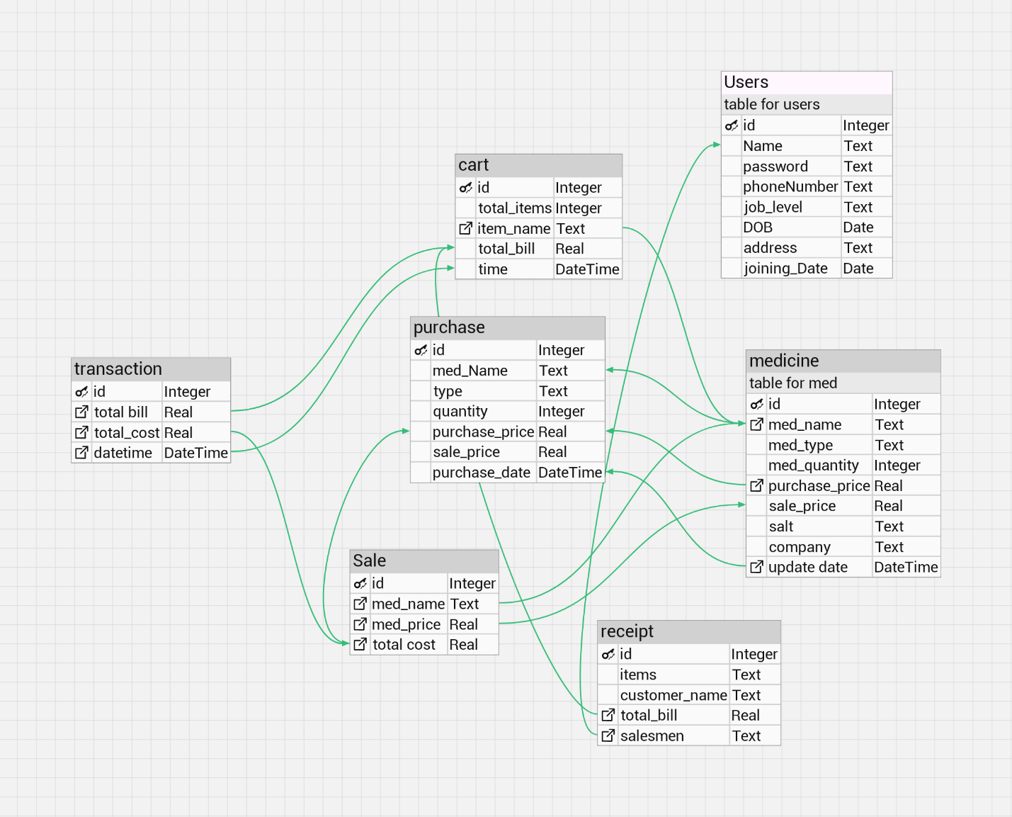

## Graphical User Interfaces

Login Page

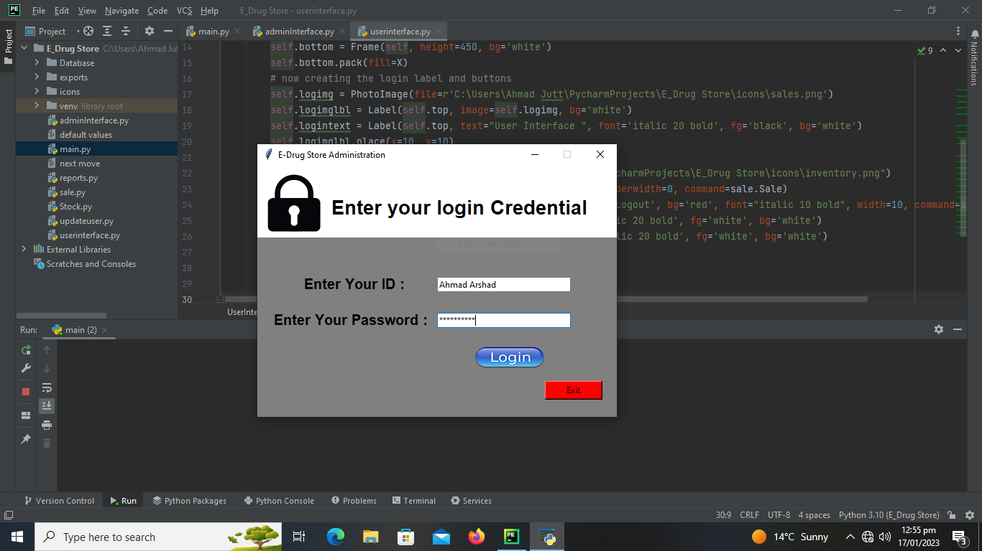

Admin Panel

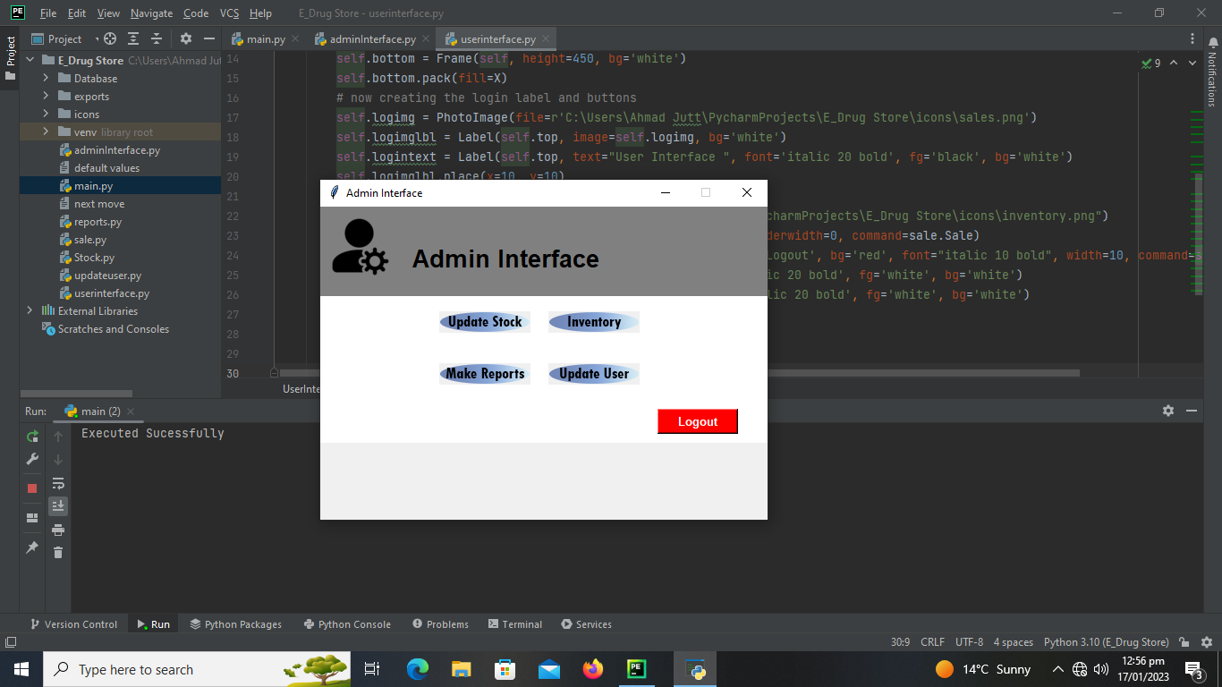

Manage User Interface

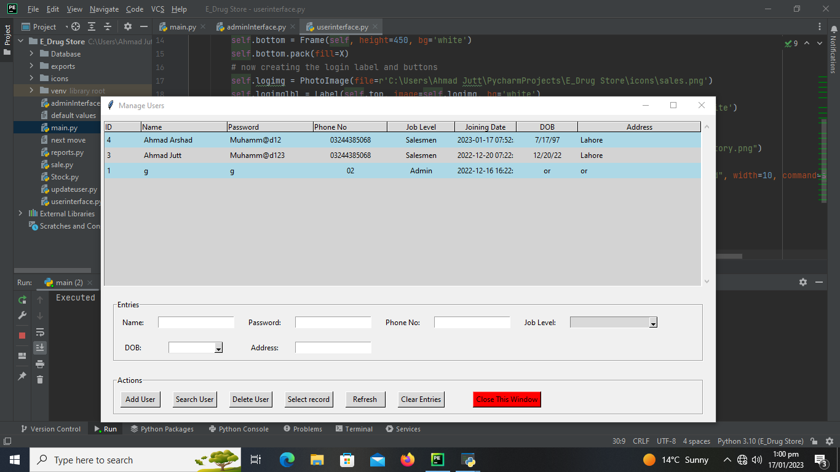

Report GUI

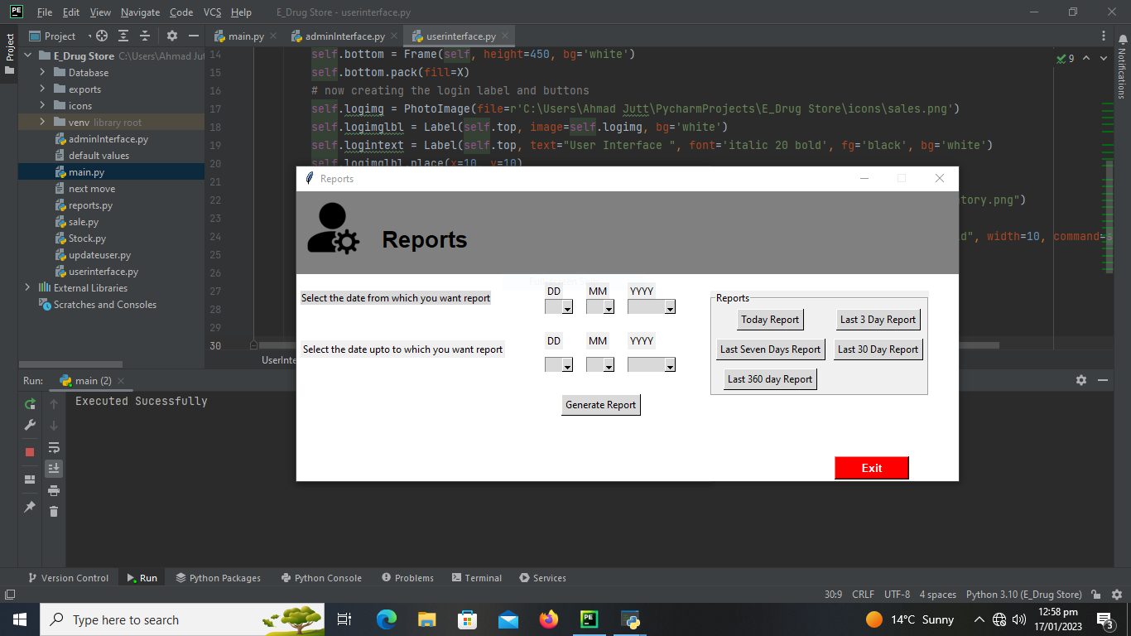

INVENTORY SALE GUI

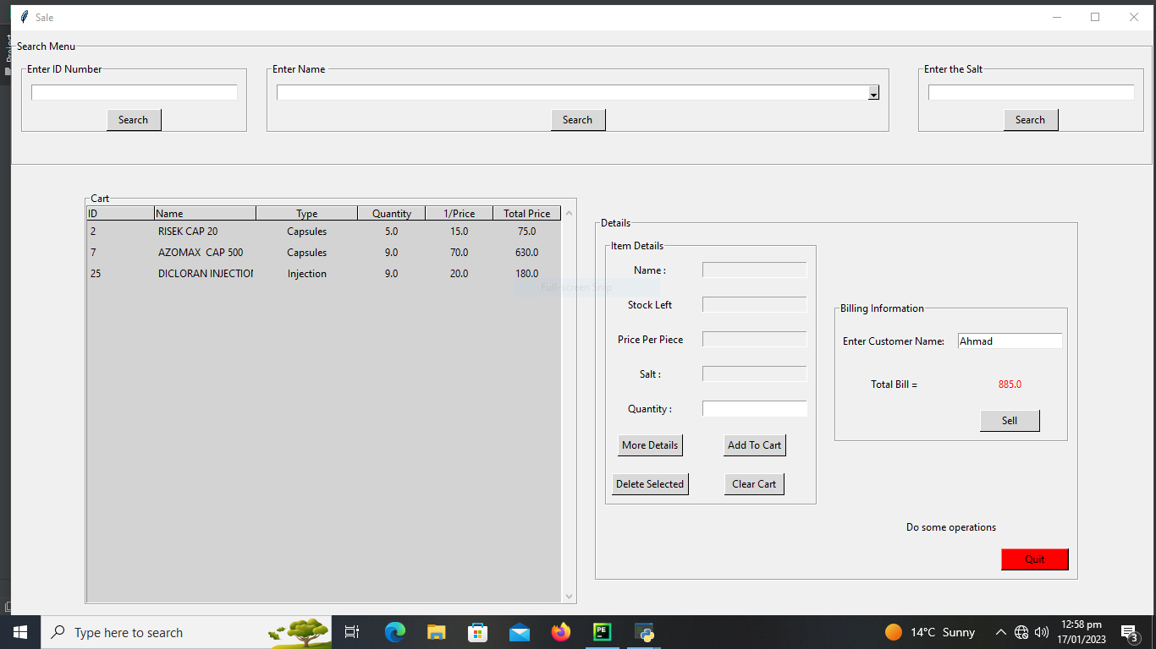

SALESMEN PANEL

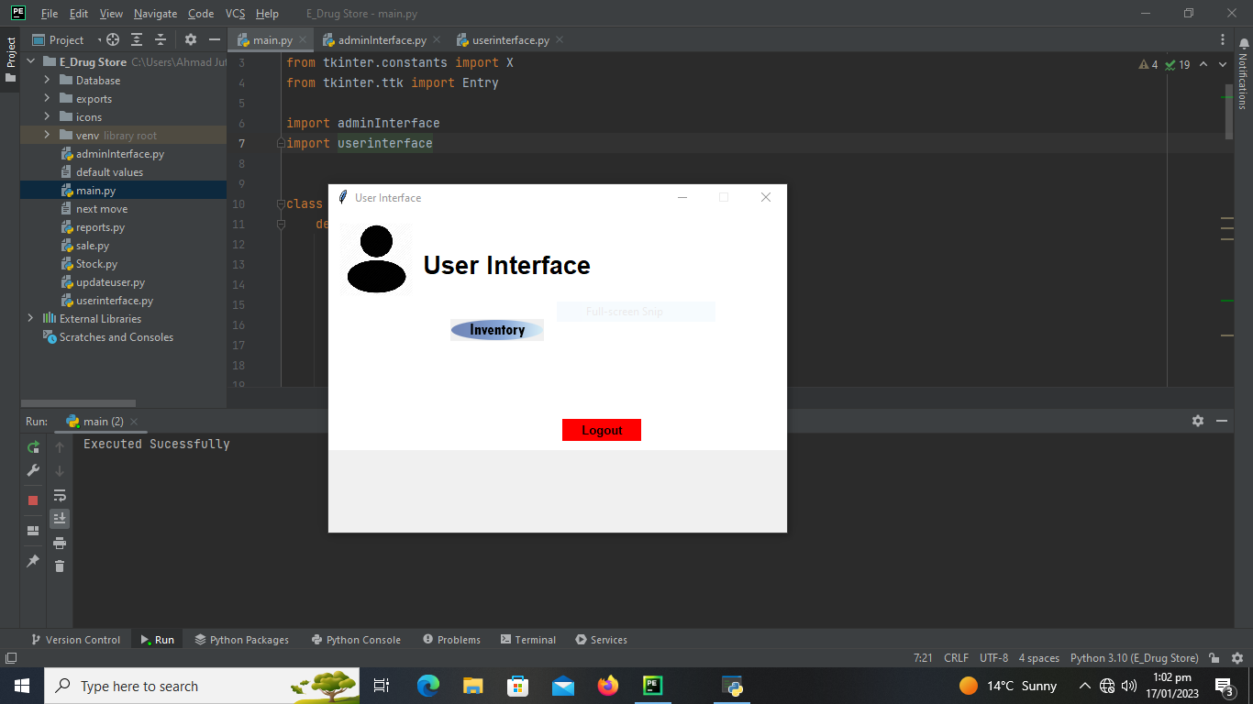

MANAGE STOCK INTERFACE

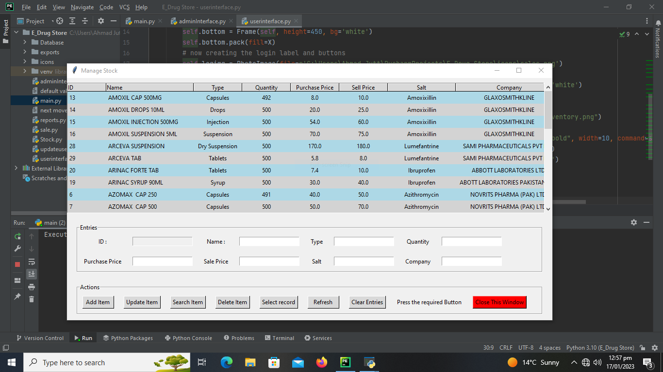

# *CHEPTER 3*

# *DEVELOPMENT*

## REFERENCES

|  |  |  |
| --- | --- | --- |
| No. | Material | Link |
| 1 | Tutorial | <https://www.codewithharry.com/videos/python-tutorial-easy-for-beginners/> |
| 2 | Tutorial | <https://www.w3schools.com/python/> |
| 3 | Tutorial | <https://docs.python.org/3/tutorial/> |
| 4 | Notes | <https://www.youtube.com/codewithharry> |
| 5 | Notes | <https://www.pythontutorial.net/> |
| 6 | Handout | Cs504: Software engineering 1 |
| 7 | Handouts | Cs403: Database Management System |
| 8 | Handouts | Cs615: Software Project Management |

Author: Ahmad Arshad

Student ID: BC170202448

Email:bc170202448@vu.edu.pk

ahmadarshad12345@gmail.com

## Appendix

|  |  |
| --- | --- |
| Chapter 1 | Gathering and analyzing info |
| Chapter 2 | **Designing the project** |
| Chapter 3 | **Development** |